EXPERIMENT 6

Name: Arav Desai | Roll No: 3
Subject: OOP | Class/Batch: AIML A
Date of Performance: 14/8/2024 | Date of Submission:

Code

- Write a program to check if the entered number is Armstrong or not

import java.util.Scanner;
class array1
{ public static void main(String args[])
{Scanner in=new Scanner(System.in);
int n;
System.out.println(" ENTER THE SIZE OF ARRAY");
n=in.nextInt();
int a[]= new int[n];
System.out.println(" Enter elements of array ");
for (int i=0;i<n;i++)
{
a[i]=in.nextInt();
}
System.out.println("THE ARRAY IS ");
for(int i=0;i<n;i++)
{
System.out.println(+a[i]);
}
}
}
Output
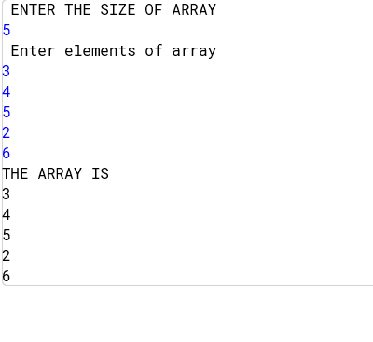

Code
Program to demonstrates System.arraycopy() function
class Arraycopy
{
public static void main(String args[ ])
{
int Array1[] = {10,20,30,40,50,60,70,80,90,100};
int Array2[] = {1,2,3,4,5,6,7,8,9,10};

System.out.println("The first array is:");
for (int i = 0; i < 10; i++)
System.out.print(Array1[i]+"\t");
System.out.println();

System.out.println("The second array is:");
for (int i = 0; i < 10; i++)
System.out.print(Array2[i]+"\t");

System.out.println();
System.arraycopy(Array1,5,Array2,5,5);

System.out.println("The second array after calling arraycopy( ) : ");
for (int i = 0; i < 10; i++)
System.out.print(Array2[i]+"\t");

}
}

Output

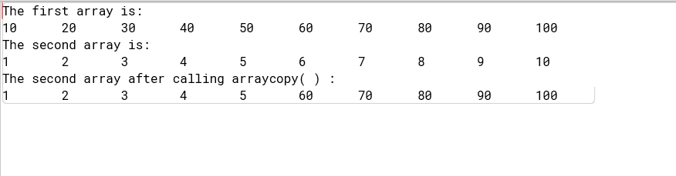

Code

Program to calculate average of 5 numbers using Array
class ArrayDemo1
{
public static void main(String args[])
{
int number[] = new int[5];
int sum=0;

number[0]=5;
number[1]=10;
number[2]=15;
number[3]=20;
number[4]=25;

for(int i=0;i<5;i++)
sum=sum+number[i];

System.out.println("Average is : "+sum/5);
}
}

Output

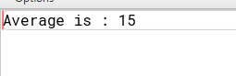

Code

Program to demonsrates the - toUpperCase( ) and toLOwerCase( )
class CaseDemo
{
public static void main(String args[ ])
{
String str1 = "MAHATMA";
String str2 = "gandhi";
String temp;

System.out.println("Original String1 is : "+str1);
temp=str1.toLowerCase();
System.out.println("After calling toLowerCase(), String1 is : "+temp);

System.out.println("\nOriginal String2 is : "+str2);
temp=str2.toUpperCase();
System.out.println("After calling toUpperCase(), String2 is : "+temp);
}
}

Output

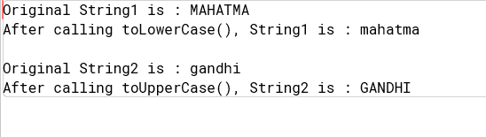
Code
Program to demonstrates the - charAt( )
class charAtDemo
{
public static void main(String args[ ])
{
String s = "INDIA";
char ch;

System.out.println("String is : "+s);
ch= s. charAt(2);
System.out.println("Character at Index 2 (i.e. 3rd position) is : "+ch);
}
}

Output

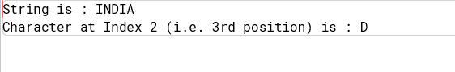

Code
Program to demonstrates the - concat( )
class concatDemo
{
public static void main(String args[ ])
{
String s1 ="Abdul";
String s2 =" Kalam";

System.out.println("String1 is : "+s1);
System.out.println("String2 is : "+s2);

String temp = s1.concat(s2); // calling concat() function

System.out.println("\nConcatenated String after calling concat( ) : "+temp);

temp= s1 + s2; // using + operator to concatenate
System.out.println("Concatenated String after applying '+' operator : "+temp);
}
}

Output
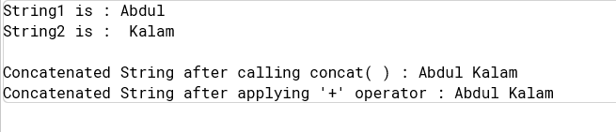

Code

Program to demonstrates the - equals() Versus ==
class equals_vs_equalstooperatorDemo
{
public static void main(String args[ ])
{
String s1="Java";
String s2=new String(s1);

System.out.println(s1+" equals "+s2+" --> "+ s1.equals(s2));
System.out.println(s1+" == "+s2+" --> "+ (s1==s2));
}
}

Output
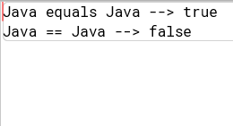

Code
Program to calculate length of string
class lengthDemo
{
public static void main(String args[ ])
{
String str = "INDIA"; // use string literal
System.out.println(" String is : "+str);
System.out.println(" Length of String is : "+str.length());
}
}

Output
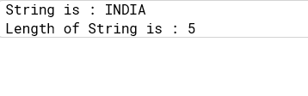

Code
Program to search a given integer in an array of integers
import java.io.DataInputStream; // to load DataInputStream class

class P2
{
public static void main(String args[ ])
{
int arr[]= new int[20];
int num=0, i, subscript;
DataInputStream in = new DataInputStream(System.in);

try
{
System.out.println(" Input 5 array elements : ");
for(i=0;i<5;i++)
arr[i] = Integer.parseInt(in.readLine());
System.out.print(" Enter number to be searched : ");
num= Integer.parseInt(in.readLine());
}
catch(Exception e) { System.out.println("I/O Error"); }

if((subscript = search(arr,num)) == -1)
System.out.println(" No such element !! ");
else
System.out.println(" Element found at : "+subscript);
}

static int search(int arr[], int num)
{
int i ;
for(i=0; i<5; i++)
if (arr[i] == num)
return (i+1);
return -1;
}

}

Output
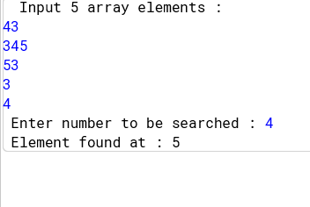

Code
Program to check whether given string is a palindrome or not
class P16
{
public static void main(String args[ ])
{
String str = new String("MALAYALAM");
int i,j,len = str.length();
boolean flag=true;

System.out.println("String :"+str);
for(i=0,j=len-1;i<=len/2;i++,j--)
{
if(str.charAt(i)==str.charAt(j))
flag=true;
else
{
flag=false;
break;
}
}

if(flag==true)
System.out.println("String is palindrome");
else
System.out.println("String is not palindrome");
}

}

Output
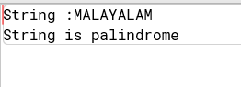

Code
Program to demonstrates the - replace( )
class replaceDemo
{
public static void main(String args[ ])
{
String s1 = "Bye Bye !!";
String s2= s1. replace('y','e');

System.out.println("Original String is : "+s1);
System.out.println("String after calling relace() : "+s2);
}
}

Output
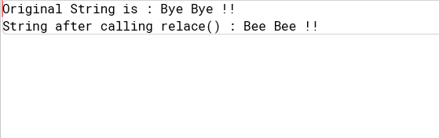

Code
Program to demonstrate StringBuffer Methods
class StringBufferDemo
{
public static void main(String args[ ])
{
// using length() and capacity()
StringBuffer sb= new StringBuffer("Java");
System.out.println("\n StringBuffer : "+sb);

System.out.println("\n********** length() and capacity() **************");
System.out.println("\n Length : "+sb.length());
System.out.println("\n Capacity : "+sb.capacity());

// using ensureCapacity()
System.out.println("\n\n********** ensureCapacity() **************");
System.out.println("\n Allocating room for 50 extra characters");

sb.ensureCapacity(50);
System.out.println(" \n New Capacity after calling ensureCapacity(50) : "+sb.capacity());

// using setLength()
System.out.println("\n\n********** setLength() **************");
System.out.println("When you increase the size of the buffer , null characters are added to the end of the existing buffer.");

sb.setLength(2);
System.out.println("\nNew Length after calling setLength(2) : "+sb.length());
System.out.println("\n StringBUffer after setting new length : "+sb);

// using charAt() and setCharAt()
sb = new StringBuffer("Java");
System.out.println("\n\n********** charAt() and setCharAt() **************");
System.out.println("\nStringBuffer : "+sb);
System.out.println("\ncharAt(0) before : "+sb.charAt(0));

sb.setCharAt(0,'K');
System.out.println("\nNew StringBuffer : "+sb);
System.out.println("\ncharAt(0) after : "+sb.charAt(0));

// using append()
System.out.println("\n\n********** append() **************");
StringBuffer sb1 = new StringBuffer(40);

String s = sb1.append(" X = ").append(100).append(".").toString();
System.out.println("\nAfter calling append(), String is : \n");
System.out.println(s);

// using insert()
System.out.println("\n\n********** insert() **************");
sb = new StringBuffer("Java is a true oriented Language");
System.out.println("\nStringBuffer : "+sb);

sb.insert(15, "object-");
System.out.println("\n calling insert().....");
System.out.println("\nAfter inserting 'object-' in StringBuffer, New String is :"+sb);

// using reverse()
System.out.println("\n\n********** reverse() **************");
sb = new StringBuffer("JAVA");
System.out.println("\nStringBuffer : "+sb);
sb.reverse();
System.out.println("\nAfter calling reverse() new StringBuffer : "+sb);

// using delete() and deleteCharAt()
System.out.println("\n\n********** delete() and deleteCharAt() **************");
sb = new StringBuffer("Java is a true object-oriented Language");
System.out.println("\nStringBuffer : "+sb);
sb.delete(9,14);
System.out.println("\n calling delete().....");
System.out.println("\nAfter deleting 'true' from StringBuffer, New StringBuffer : \n"+sb);

sb.deleteCharAt(0);
System.out.println("\n calling deleteCharAt().....");
System.out.println("\nAfter deleting first character, New StringBuffer: \n"+sb);

// using replace()
System.out.println("\n\n********** replace() **************");
sb = new StringBuffer("He is Superstar.");
System.out.println("\nStringBuffer : "+sb);

sb.replace(3,5,"was");
System.out.println("\ncalling replace()......");
System.out.println("\nAfter replacing 'is' with 'was', New StringBuffer : "+sb);

// using substring()
System.out.println("\n\n********** substring() **************");
sb = new StringBuffer("He is Superstar.");
System.out.println("\nStringBuffer : "+sb);

s = sb.substring(6,11);
System.out.println("\n calling substring().....");
System.out.println("Retriving 'Super' from StringBuffer, New StringBuffer : "+s);

}
}
Output
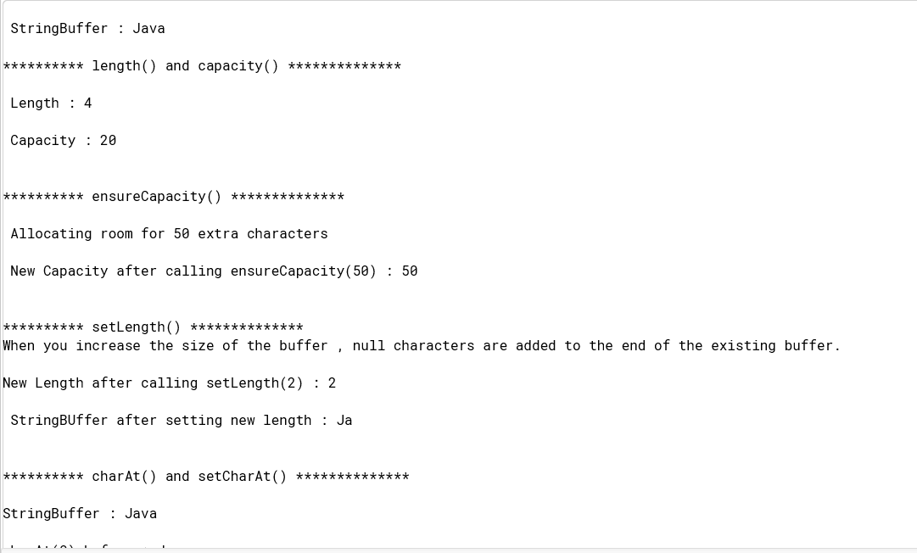
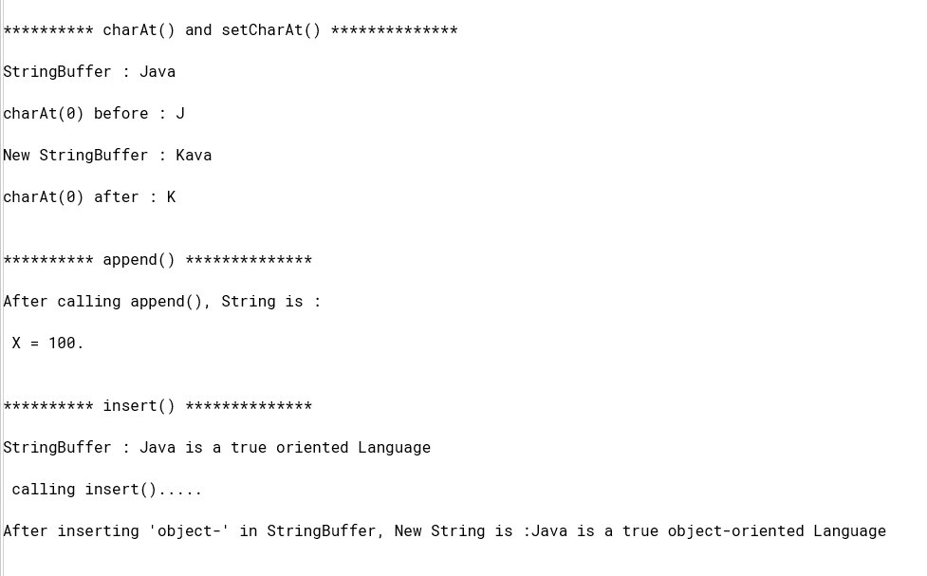
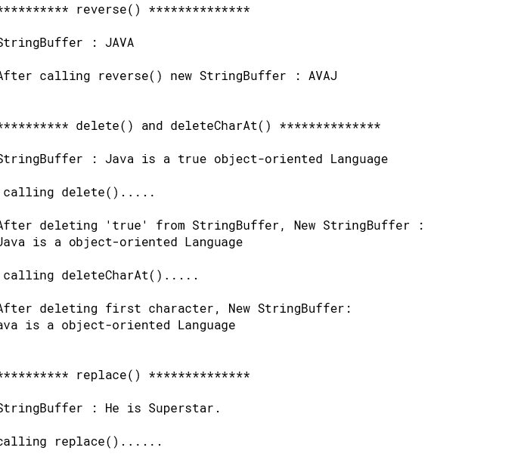

Code
Program which concatenates a string
class P18
{
public static void main(String args[ ])
{
StringBuffer str1 = new StringBuffer("Good ");
String str2 = new String("Day");

System.out.println(" String1 is : "+str1);
System.out.println(" String2 is : "+str2);

str1 = str1.append(str2);
System.out.println(" String after concatenation : "+str1);
}
}

Output

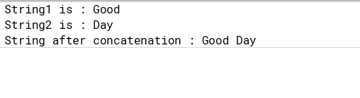
Code
Program to demonstrates the - toCharArray( )
class toCharArrayDemo
{
public static void main(String args[ ])
{
String s =" Java is Object Oriented Language";
char ch[]= new char[s.length()];

ch=s.toCharArray();
System.out.println("All characters in a String object is converted to character Array..");
System.out.println(ch);
}
}
Output

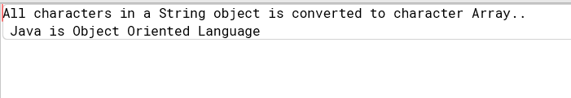

Code
Program to demonstrate - toString()
class Rectangle
{
int length;
int width;

Rectangle(int l,int w)
{
length = l;
width = w;
}

public String toString()
{
return "Dimensions are "+length+" by "+width+".";
}

}

class toStringDemo
{
public static void main(String args[])
{
Rectangle rect = new Rectangle(20,15);
String s = "Rectangle rect : " +rect; // concatenate Rectangle object

System.out.println(rect); // convert Rectangle to String
System.out.println(s);
}
}

Output
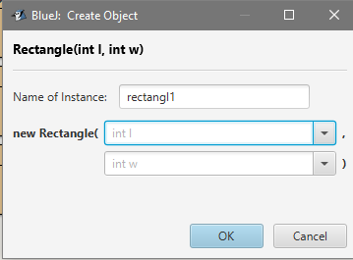
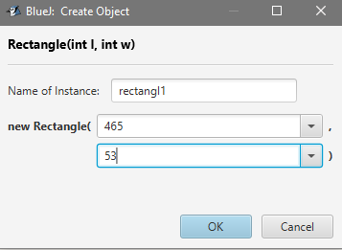
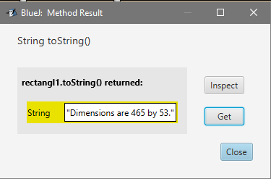

Code
import java.util.*;
class transpose
{
public static void main(String args[])
{
scanner s=new scanner(System.in);
int n,m,i,j,temp;
System.out.println("Enter the number of rows and columns of the square matrix");
m=s.nextInt();
n=s.nextInt();
int a[][]=new int[m][n];
System.out.println("Enter the elements of the square matrix");
for(i=0;i<m;i++)
{
for(j=0;j<n;j++)
{

a[i][j]=s.nextInt();
}
}
System.out.println("the original matrix is\n");
for(i=0;i<m;i++)
{
for(j=0;j<n;j++)
{
System.out.println(""+a[i][j]+"");
}
System.out.println("");
}

for(i=0;i<m;i++)
{
for(j=0;j<n;j++)

{
a[i][j]=a[j][i];
}
}
System.out.println("the tranpose matrix is\n");
for(i=0;i<m;i++)
{
for(j=0;j<n;j++)
{
System.out.println(""+b[i][j]+"");
} //end of for
}
}
}
Output
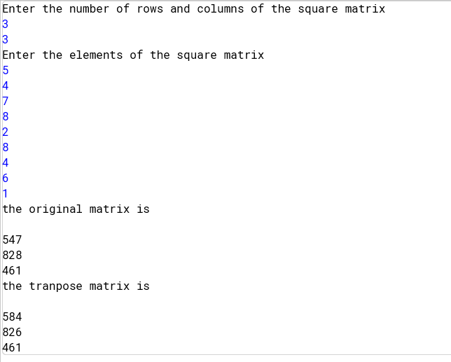

Code
Vector implementation
import java.util.*;
class vector
{
public static void main(String a[])
{
Vector v=new Vector(); // creating a vector
Scanner ob=new Scanner(System.in);
String name;
int c=0,i=1,l;
do
{
System.out.print("1. Enter\n2. Delete\n3. Display\n Enter Your Choice: ");
c=ob.nextInt();
switch(c)
{
case 1:
System.out.print("Enter The name of the City: ");
name=ob.nextLine();
name=ob.nextLine();
if(v.contains(name))
System.out.println("Name Already Exists !");
else
v.addElement(name);
break;
case 2:
System.out.print("Enter the name of the City: ");
name=ob.next();
if(v.contains(name))
v.removeElement(name);
else
System.out.println(" Name Not Found !");
break;
case 3:
System.out.println("Name of the Cities are: ");
Enumeration e=v.elements();
//use of enum function
while(e.hasMoreElements())
System.out.println(i+". "+e.nextElement());
++i;;
break;
default:
System.out.println(" enter a valid choice!");
}// end of switch
System.out.print("Press 1 to continue again \n ");
l=ob.nextInt();
}while(l==1);
}
}
Output
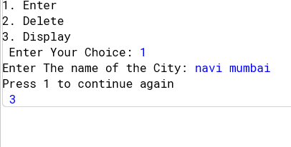
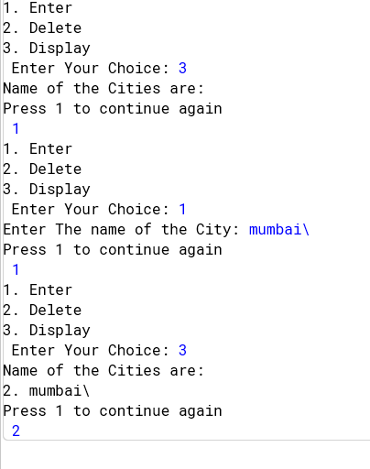

Conclusion

Assessment

Timely Submission  (7) | Presentation  (06) | Understanding  (12) | Total  (25) | Sign

